index.php

//2-

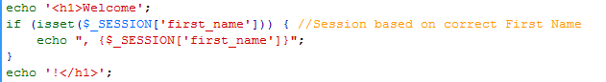

change_password.php

//2-

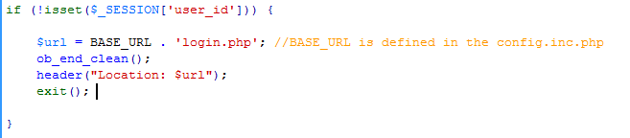

login.php

//2-

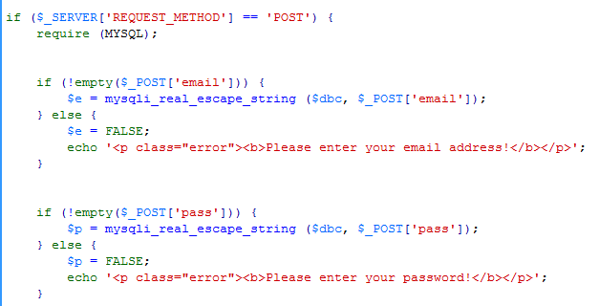

logout.php

//2-

